# Appendix 03:

**Guideline for using Bizagi to draw the BPMN process**

1. **Introduction**
2. ***Overview:***

* Bizagi Modeler is a free tool for flowchart and process documentation developed by Bizagi company. This tool allows us to visually draw flowcharts and document business processes with the standard BPMN (Business Process Model and Notation) format. BPMN is a widely accepted process flowchart language around the world.
* For more information about BPMN, visit <http://www.omg.org/spec/BPMN/2.0>
* Bizagi Modeler also provides a feature that allows us to run simulations to find errors in the built process, analyze time and resources to optimize the process. Bizagi Modeler allows to publish process documents in Word, PDF, SharePoint or Wiki formats with high quality.
* Processes can also be easily imported from or exported to Visio or XML and several other tools. Bizagi Modelr has a friendly, user-friendly interface like the software in Microsoft's Office suite. On the editor screen can display multiple flowcharts placed in tabs, and easily move between tabs. A model can contain one or more flowcharts.
* 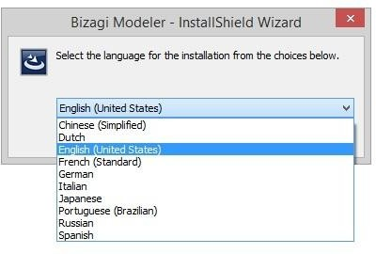A file is interpreted as a model, and can be saved in two formats: .bpm (for individual work) or .bpmc (for collaborative group work). Bizagi Modeler is a multilingual tool, the user interface is available in the many languages.
* Or you can change the desired language by selecting the language in the interface 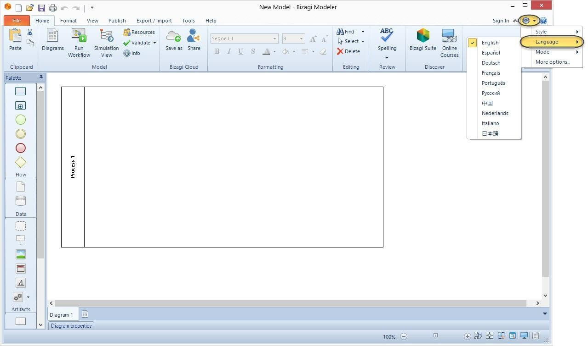menu bar

1. ***Training and support:***

* Bizagi Modeler provides several types of support to help you model and document the process.
* We can select these supports via the Help tab on the interface, which requires internet to connect.
  + Video Tutorials: provide short videos to explain and introduce new features: [Link Video](http://www.bizagi.com/container/video_tutorial_modeler_en.html).
  + Support Forums: you need to register to join the free forum, your questions will be answered quickly by the user community and experts of Bizagi. [Link Forums.](http://feedback.bizagi.com/en/)
  + Free Process Xchange: a collection of common sample processes that have been used successfully in many organizations. You can download and use, or edit to suit the unit. [Link Process Xchange.](http://www.bizagi.com/en/community/process-xchange)
  + Help: includes many online documents that provide the knowledge you need to draw diagrams and document processes. You can download the User guide for offline use.

1. ***Products in Bizagi BPM Suite***

* Bizagi BPM Suite is a set of 3 products: Bizagi Modeler, Bizagi Studio, Bizagi Engine. After you have drawn a flowchart with Bizagi Modeler, you use Bizagi Studio and Bizagi Engine to automate the process and convert it to a system that can execute the process. Bizagi Studio allows us to enter all the necessary information for the execution of the process such as: standard time, cost, user interface, rules, etc. This information is saved as a model in a database and is used at runtime by the Bizagi Engine when executing a process through an end-user portal. You can find more information about BPM Suite by following [link](http://www.bizagi.com/en/bpm-suite) .

1. **Instructions for installing Bizagi Modeler on PC**
2. ***Operating system and hardware requirements***

To install Bizagi Modeler, the PC must meet the minimum requirements as below.

* Operating system requirements: Windows 10, Windows 8.1, Windows 8, Windows 7, Windows Vista, Windows Server 2012, Windows Server 2008 R2/2008.
* Software requirements: Microsoft .NET Framework 4.5.2 [Download th](https://www.microsoft.com/en-us/download/details.aspx?id=42642)e [.NE](https://www.microsoft.com/en-us/download/details.aspx?id=42642)T [Framework](https://www.microsoft.com/en-us/download/details.aspx?id=42642)
* Hardware requirements: Processor: 1 GHz. 32-bit (x86) or 64-bit (x64); RAM: 1 GB (32-bit) or 2 GB (x64); Hard drive: 50MB free space; Screen resolution: 800 x 600 or higher.
* To view documents and work in the Cloud: Internet Explorer (9,10,11), Chrome, Mozilla Firefox; Microsoft Word 2013, 2010, 2007; Microsoft Visio 2010, 2007, 2003; Microsoft Office SharePoint Server 2010/2007 and SharePoint Services 3.0; MediaWiki 1.14 to 1.22.

1. ***Installation instructions***

* You can download the Bizagi Modeler software from the website at the following link http://www.bizagi.com/en/products/bpm-suite/modeler.
* Click the Download button Bizagi Modeler, the website will ask you to register as a member to be able to download. After registering as a member, you can download software, can join Forums, use Cloud functions and get 10Mb storage for free on Cloud.
* After downloading the modeler installer to your computer, we proceed to install it. 4 Select the language you want to install from the list.

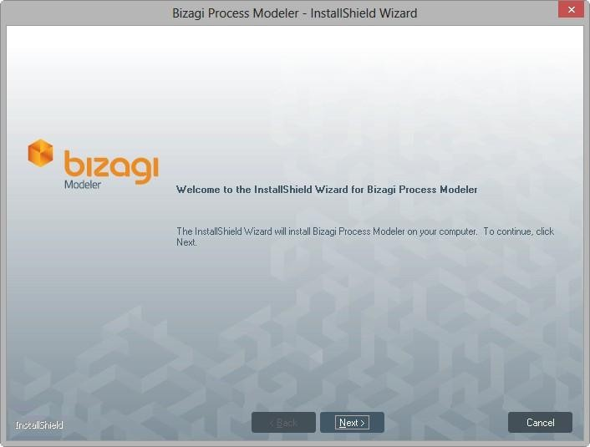

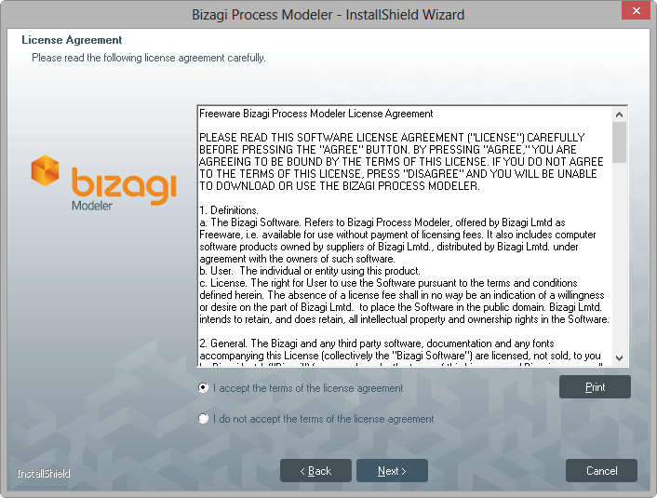

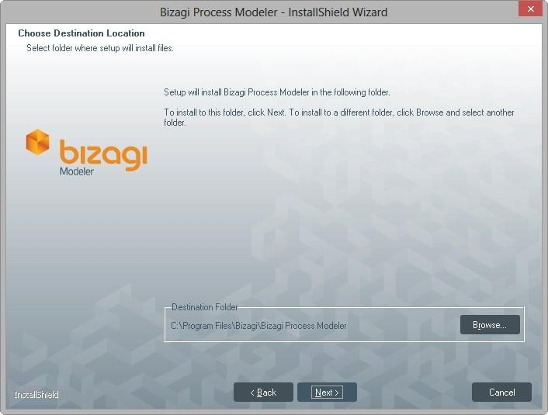

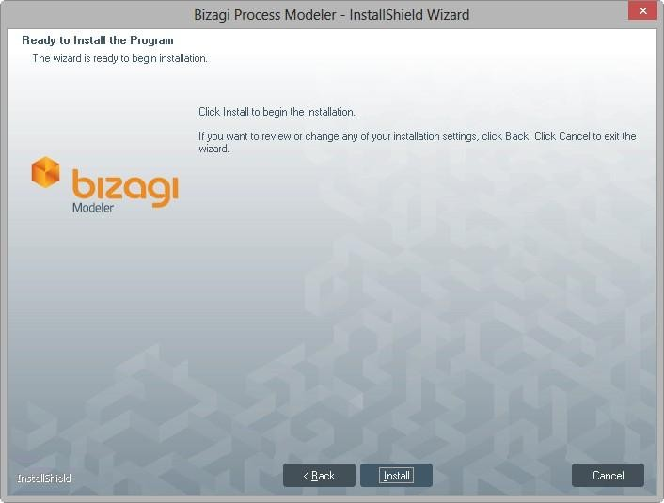

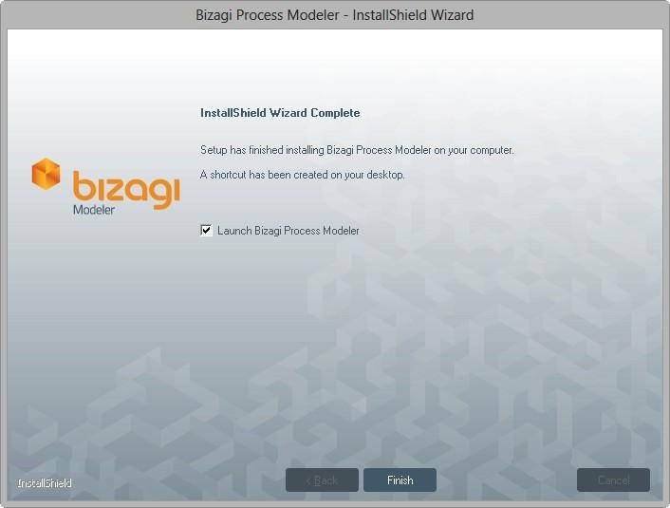

1. **Using Bizagi Modeler**
2. **User Interface**

Bizagi Modeler has a very simple user interface, easy to use and very intuitive, familiar. It has 5 main components: Toolbar, Ribbon, Palette, Element Properties and View.

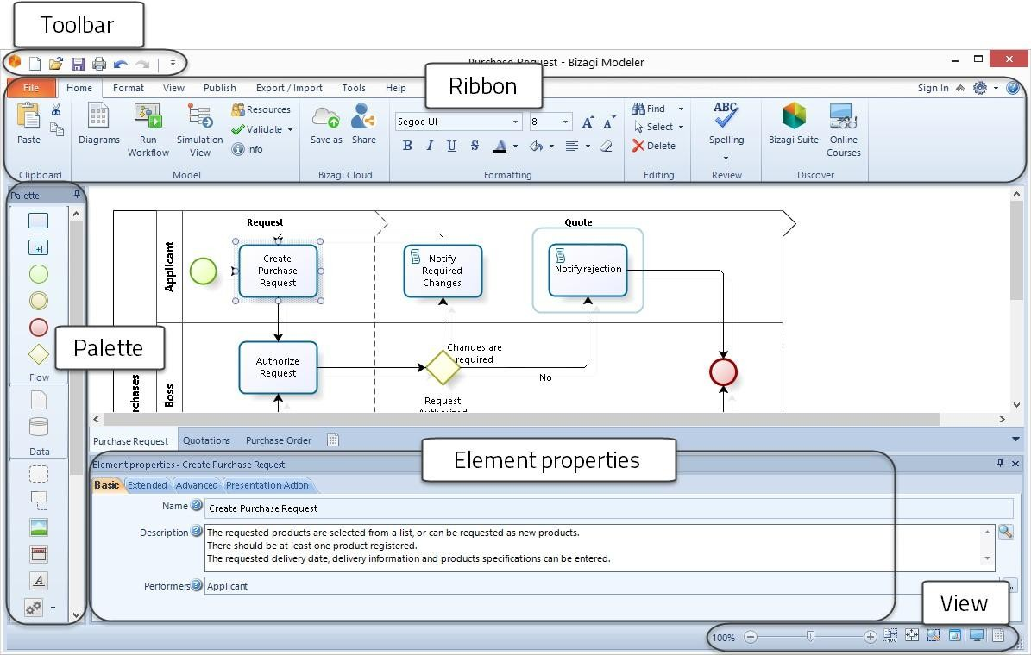

1. **How to draw flowcharts**

Bizagi supports drag-and-drop elements for drawing diagrams from the palette, and quick drawing of components in the flow is done from the pie menus of other components. When opening the program, Bizagi already has a pool available for you to manipulate.

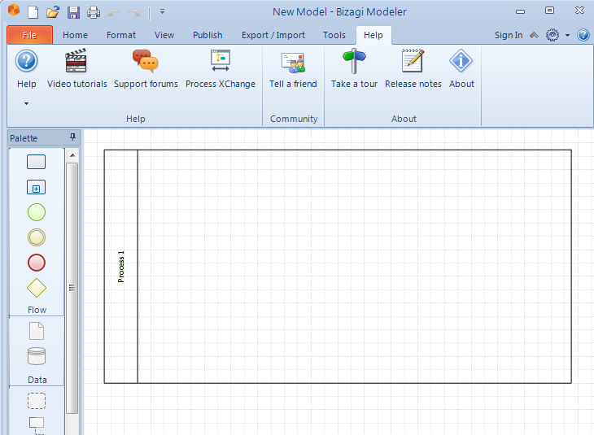

Pool will be the framework for drawing an entire flowchart. You can drag more lanes to subdivide the pool to clearly see the roles in the process. The lanes will divide the pool horizontally.

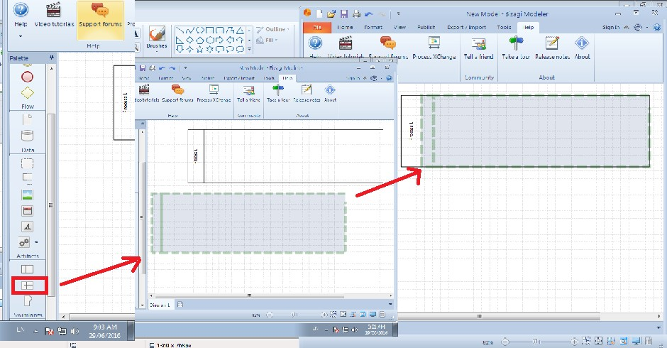

You can drag more milestones to highlight milestones, major stages in the process. The milestones will split You can drag more milestones to highlight milestones, major stages in the process. The milestones will split the pool vertically.

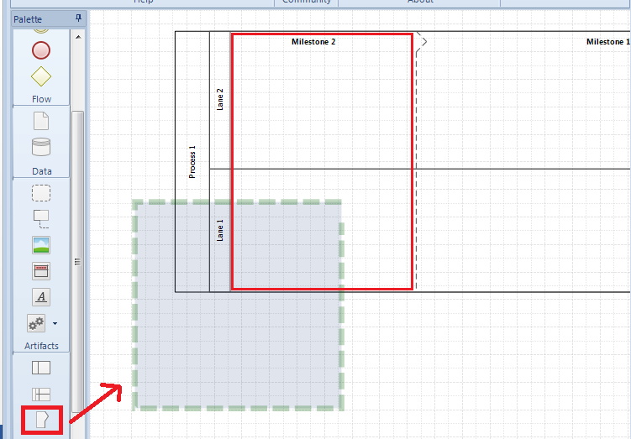

You can drag and drop to move pool, lane, milestone, or resize them.

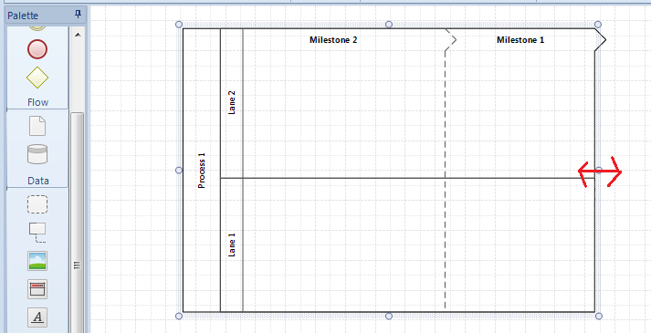

You can edit the element names by double-clicking or right-clicking and choosing Edit Text.

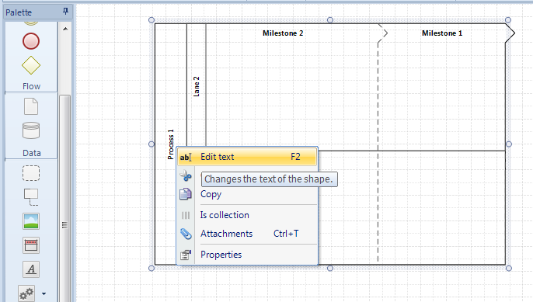

To start the process, we drag the Start Event to the pool. Enter a name for the Start Event if desired.

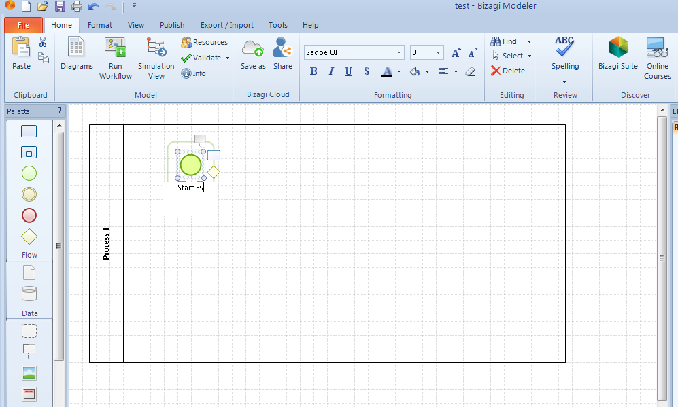

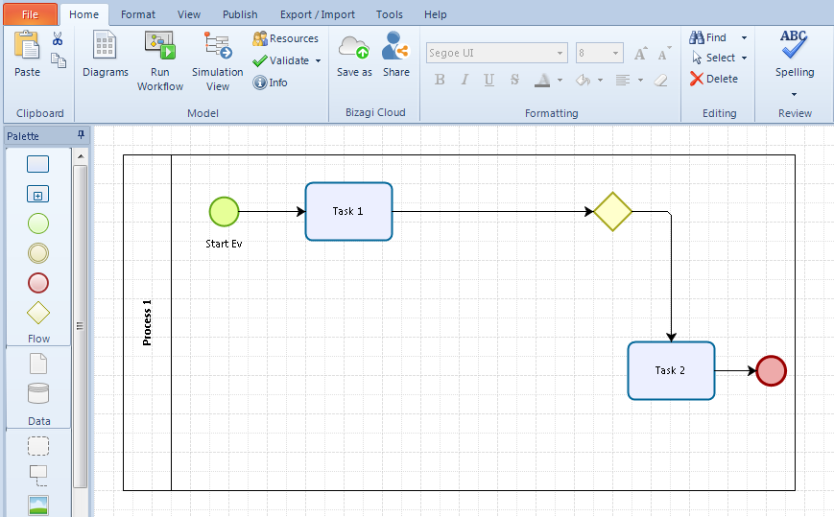From the pie menu, draw the desired next shapes by selecting the icon and dragging it to the desired position.

If you want to insert another element between the two, just drag and drop in the middle of the connection line between them. Bizagi will automatically join the components together

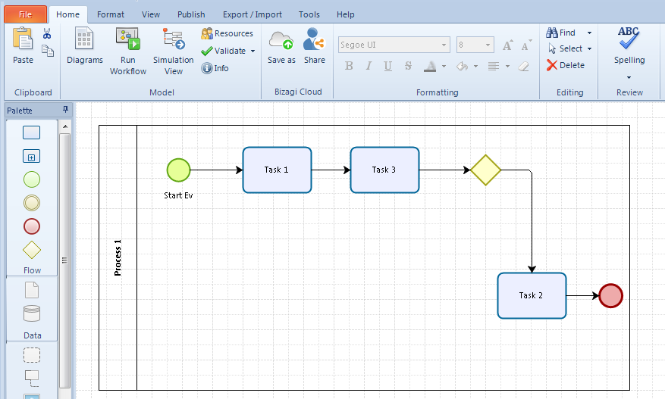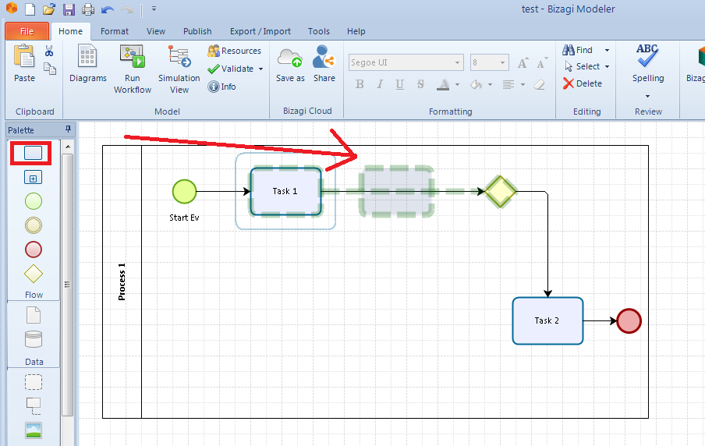

You can change the position of the arrows by clicking on it, selecting the beginning or the end and dragging to the desired position, when the X appears, it is OK.

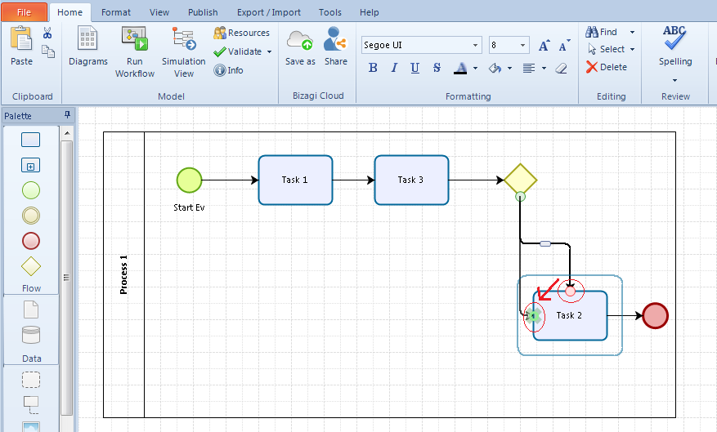

When converting a Task (work) to a sub-process (subprocess), the symbol of the task will change to the symbol of the sub-process, the name of the Task will move from the middle to the outside and to the bottom of the rectangle.

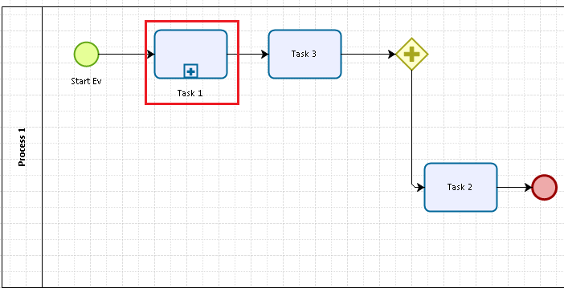

We draw the flowchart for the sub-process by right-clicking and selecting Edit Sub-Process, the flowchart screen for the Sub-process will appear. If it is a normal sub-process then there will be no pool, lane, milestone, just other components; if it is reusble sub-process (reusable sub-process) then there will be full pool, lane, milestone like plotting for main process. If you attach an Event (event) to a Task or Sub-process, you will need to draw an exception flow when encountering that Event. For example, add a Timer Event to Task 3.

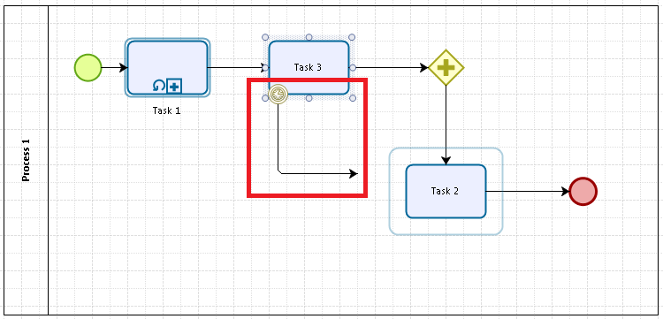

Suppose that after 3 hours of waiting, but Task 3 has not completed, it will move to another job and end the thread.

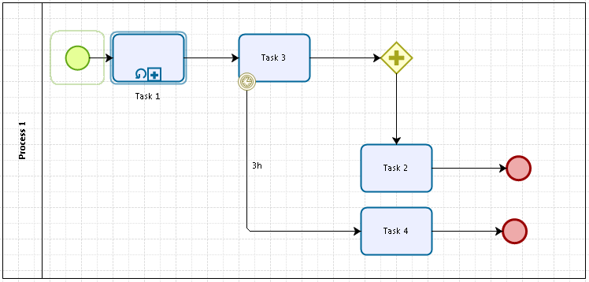

With Attach Events (the event type attached to the border of the activity) that does not interrupt the Activity it is attached to, convert it to Non-Interrupting (the event type does not stop the activity).

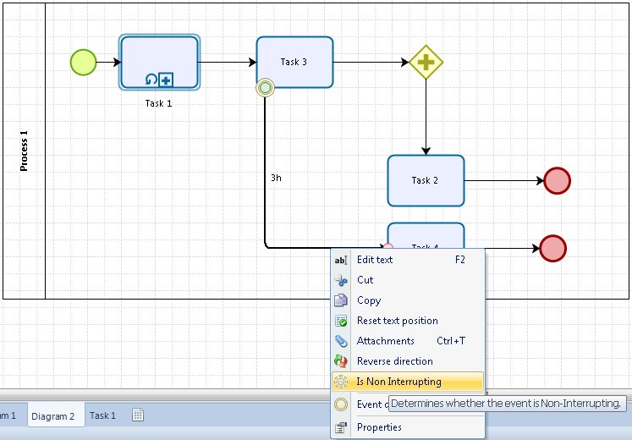

You can group some elements in a flowchart together by dragging the Group icon from the palette to the desired position, dragging or resizing the group as you like.

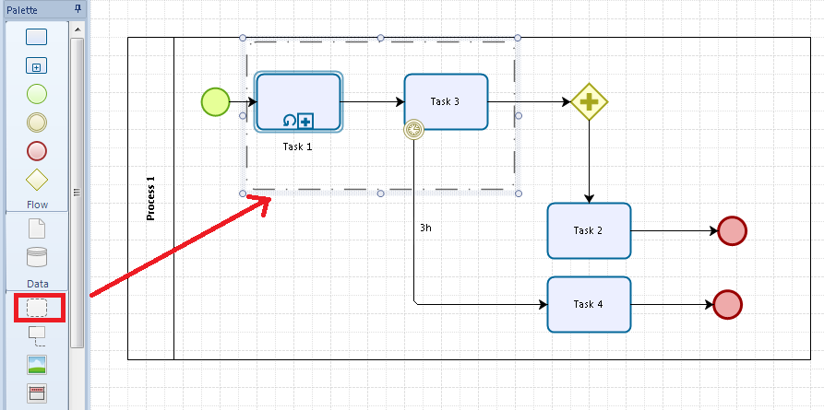

You can add annotations using Annotation , or descriptions using Formatted Text to add additional information to the flowchart.

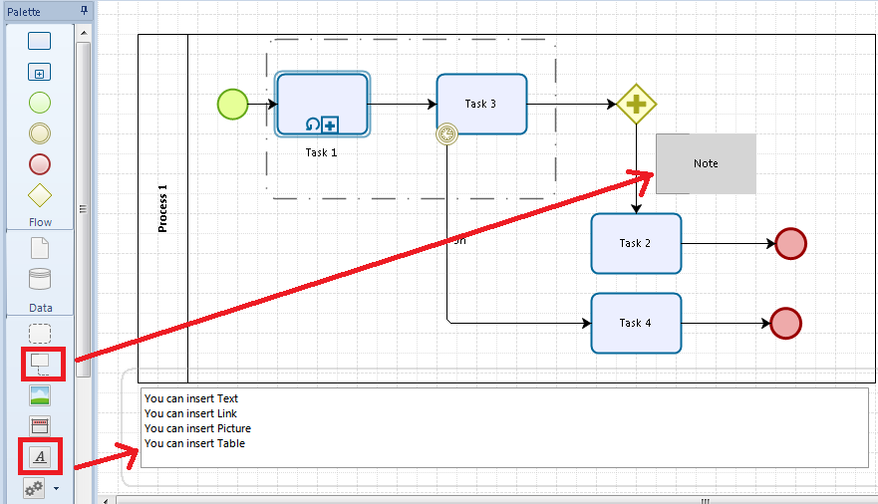

1. **Add properties (attributes) to the elements of the flowchart.**

Bizagi allows to add any attributes to the elements of the flowchart. When an element is added attributes, all elements of the same type automatically have those attributes. We right-click on the component, select Edit Properties, the properties window opens

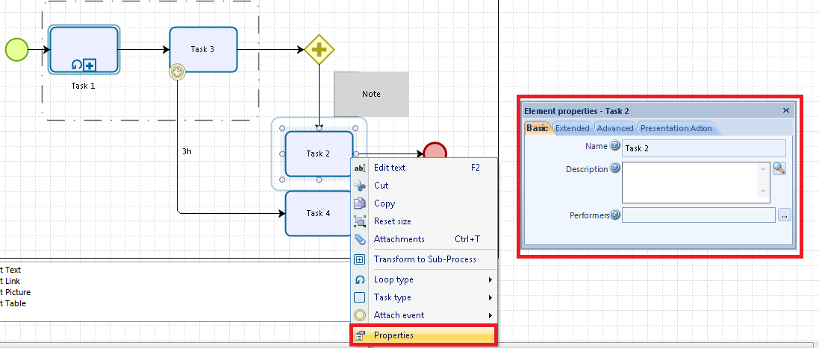

The Basic tab allows us to edit the name, write a summary description and select the performer for that Activity from the list of Performer defined. To create the Performer list, click the Resources tab on the ribbon.

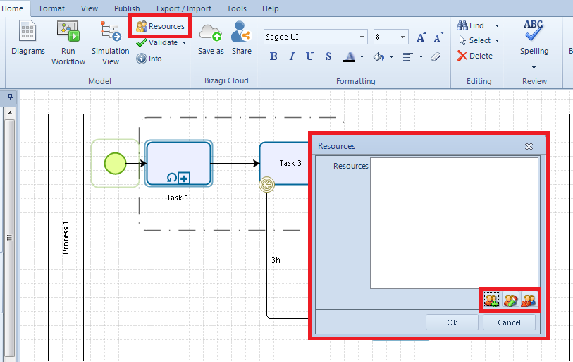

There are options to add, edit, delete. Click on the image with the green cross to add resources. Resources can be people, or entities (units, machines, etc.). The New resource screen appears, enter the name, description, and select the type and then click OK.

Now we can select the performer performing the Activity from the resource list.

1. 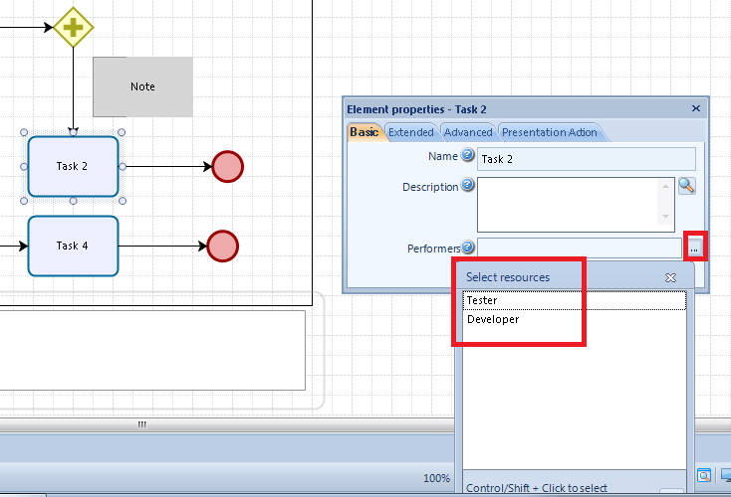**Import, Export and Publish flowcharts**

Bizagi allows you to export flowcharts, or import flowcharts in several formats: Visio, XPDL, BPMN. In addition, it is possible to export as an image, and the attributes are defined in the components to import it into another flowchart (excluding the content of the attribute). To import or export, click the Export/Import tab on the menu.

